ORGANIZATIONAL ACTIVITY REPORT JANUARY TO MARCH 2017.
This report reflects on the organizational activities carried out since the inception of the year 2017 January to march highlighting the developments, achievements, challenges and recommendations. We greatly thank everyone especially the Board, staffs and volunteers for their commitment and efforts for making this possible, below are the activities carried out within stated period.
- Rehabilitation
We have been able to provide daily meals to beneficiaries especially those who are stay at the shelter (breakfast, lunch and supper) and the drop ins during day. In addition as well atleast change in their diet once in a week which has seen a relatively drop in illness due to nutrition and an improvement in their health.
We have also catered on their welfare i.e. purchase of utensils, cooking stove and kitchen ware which has greatly helped us in providing meals in time and no longer serving in shifts hence the smooth running of our activities.
In addition we hope to purchase new mattresses, blankets, bed sheets which will see them sleep more comfortably than the depleted mattresses they sleep on although they will still sleep two due to the limited space and congestion of our shelters.
- Sports and Recreation
- Sports
We have been able to normally participate in the weekly Sunday Derby league which addresses the less-privileged & privileged children in the Kampala and showcase their talents it’s through this initiative that 3 of our boys where spotted and given bursaries at Namagabi Secondary school. Currently we are in the 5 and 6 position in under 11 and 13 respectively.
We have also been able to purchase 3 balls for which have relatively helped us during our training sessions due to the influx of more children which was overstretching the program. We were able to get three sets of jerseys from the Right to Play an international organization working with children through sports and play, the Tucheze international tournament an annual soccer gala for grassroots talent respectively.
We also brought on board the girls football initiative into our soccer program since inception we have seen the number raise steadily to 17 in total during our training sessions and all have joined willingly due to the love and passion for the game hence reducing on the idleness and related vices which would have occurred, although still lacking in many areas to further this program for its desired goal.
We also had the opportunity to enroll one of our coaches (Kasozi Richard) for a refresher course (Fufa Level 1) which has helped him and the organization to improve on his technical and tactical abilities in the game of football In his own words “I now have a different perspective and approach to the game especially in nurturing, developing and assessment of talent, I also thank my mentor for making this happen coach kennie”. We believe the children will be the primary beneficiary of this cause as one of our core values.

- Recreation.
We have introduced indoor games especially chess board and we have purchased two boards, with the incoming on board of a volunteer coach who is a developmental coach/Fide instructor has greatly seen in the broadening of our programs and engage more children especially those who have no interested the physical games, as well as build their intellectual levels which is of great advantage to their personal development.
Furthermore we are receiving an overwhelming number of children interested in the game. We hope in the near future to develop a team which will participate in tournaments and believe that it will be of great importance to the children.
- Education.
As one of our programs which we consider as a key transformation tool and knowledge impacting into the child for the betterment of his future. We have been able to enroll 17 beneficiaries into formal education i.e. primary level with 4 of them vulnerable girls as we advocate for the girl child education with full support i.e. scholastic materials and Uniform.
Furthermore we have supported the 7 pioneer secondary boys with scholastic materials those on school bursaries due to their football talents. So far we have been able to further school without any disruption of school dues.
- Early childhood Development
Through the increasing number of the less privileged and vulnerable children, we identified a gap in our community and came up with this intervention as a basics alternative to those children could not go to school due to the high cost of educational system.
We enrolled 33 beneficiaries between the ages of 3 to 11yrs at the center but due to the limited space and resources. Since the inception of this year, seen the influx in children enrolled into the program increase. Children are taught how to read and write, sounds, numerical etc. we as well provide them with breakfast as most of them have a single meal a day due to their vulnerability. We employed a fulltime Tutor to conduct normal lessons as she works in two shifts i.e. morning and evening sessions due to the overwhelming number.
This intervention is aimed at giving an educational opportunity to vulnerable and under privileged children to get an educational background like their colleagues from well to do families.
- Skills Development.
We have incorporated this program as an alternative, avenue for skills at hand for children that cannot cope up with formal education. This intervention is aimed at impacting transferable skills for self – reliance and organizational sustainability.
As a startup project, we have been able to kick start with paper bag making an activity that involves the production of environmental friendly packaging materials. We have lined up Five more projects that include Fashion and Design, Computer training and Mainteince,Metal Frabication,Carpentry and Hair dressing. These have not kicked off due to lack of resources.

- Administration
In a bid to streamline administration we have been able to recruit to a social worker who carries out administrative duties on day to day basis (intern) Mr. Arafat Ssekyanzi, Elementary tutor (Ms.Loise Tusabe), the chess tutor (Mugisha Ivan). Starting next month we hope to recruit two more volunteers (interns) one as counsellor and another as a Child development officer to assist in the day to day running of the organization. The executive director spearheads the overall administration and running of the organization
We have also been able to rent some space which also double as drop in center and as our main administrative office as required by the local council Department which has greatly helped us to run our programs more effectively and in an organized way plus putting in place the relatively the necessary administration gaps and loopholes although still bringing the gaps compared to the previous year as we were not operating in the right procedure.
We were able to purchase some relevant office equipment’s i.e. Desks, Chairs, office stationery, printer etc. We were donated a laptop from Dogood Ug which has relatively helped us in the effective and smooth running of our activities.

CHALLENGES
- Lack of enough space and congestion in our shelter which causes a lot of discomfort to the children.
- Unsecure and unsafe for the children the drop in center (office) because in the past two months we they have had two attempted burglary.
- Lack of enough soccer equipment’s compared to the overwhelming number of children involved in the activitiy.Since January we have seen the number raise to 79 including boys and girls.
- Lack of enough indoor and board games compared to the influx of children’s willness to engage in the activities.
- Lack and uncertainty of resources to facilitate the elementary tutor.
- Uncertainty of the children continuing school in the next term and lack of learning aids and training materials i.e. text books, story books etc. to further improve on their grades.
- Lack of enough space to conduct the early childhood program compared to the place which is below standards and not safe to conduct such activities.
- Lack of enough school equipment’s and materials i.e. chairs, tables, school materials, toys etc. compared to the influx of the children in this program i.e. 33 are involved in one small single room and even have to just stand when the classes are conducted also taken in shifts.
- Lack of technical support and financial support to conduct the activities involved in the skills development program to achieve its desired goal.
- The administration still lacks the necessary facility i.e. office equipment’s, stationery is still lacking, technical and logistical support plus refresher, workshops and seminars for the staffs.

Recommendation.
- We believe with the more networking and partnership with new and existing partners for resource mobilization i.e. technical, logistical and financial support.
- We hope with the seeking and securing a better, safe premise could solve the problem of congestion and ample space for our activities.
- Through soliciting and coordinating of soccer related projects to donate and collect old soccer equipment’s to use in our soccer activities especially in the diaspora with the help of well-wishers.
- Through the broadening and introduction of other indoor and board games in order to provide equal and active participation of our children.
- Seek for sponsorships especially for the educational programs, donors in the related or international schools in the diaspora to network, partner and for exchange programs.
- Create marketing and fundraising strategies for resource mobilization in the diaspora i.e. (the 1 dollar initiative).
- Seeking and bring on board donors, sponsors, well-wishers and goodwill ambassador to fundraise for the organization as in general.
- To organize and attend workshops, trainings and seminars for our staffs in order to improve the technical support.
N.B
We have a challenge of price fluctuation as earlier planned which greatly brought the expenditure to relatively be high than anticipated.Futhermore the overwhelming number of children involved in our activities yet according to our resources we were over stretched and also we could not chase them away as it could demoralize them as well we are advocates of the children and transforming our community.

APPENDIX.
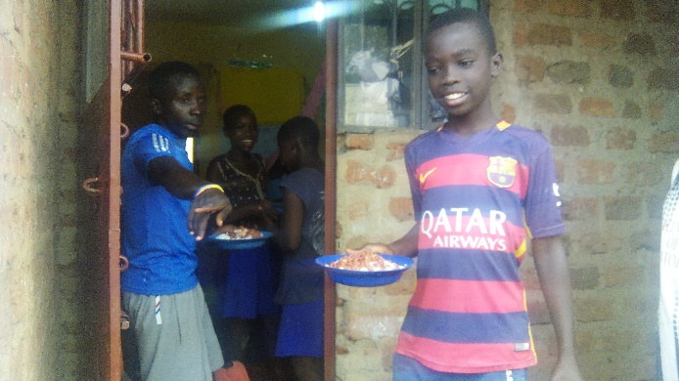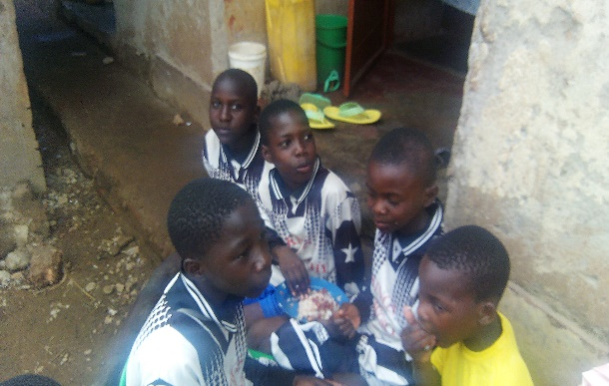
Appendix 1& 2: Some of the kids getting served their lunch and the girls who drop in enjoying their lunch.

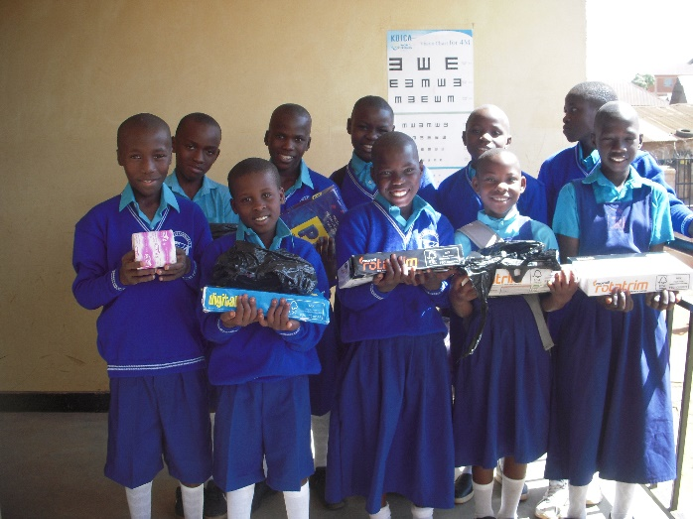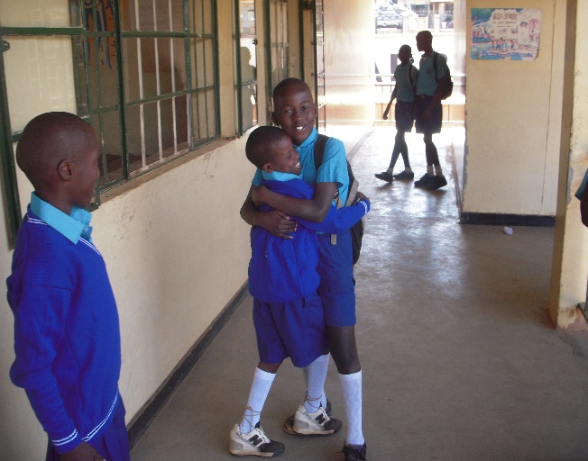
Appendix 3& 4: Some of the new enrolled children pose for a photo in their new uniforms with their scholastic materials.Francis hugs his little friend Ivan for joining him in school “I his words am excited that all now my friends at the shelter are going to school”.
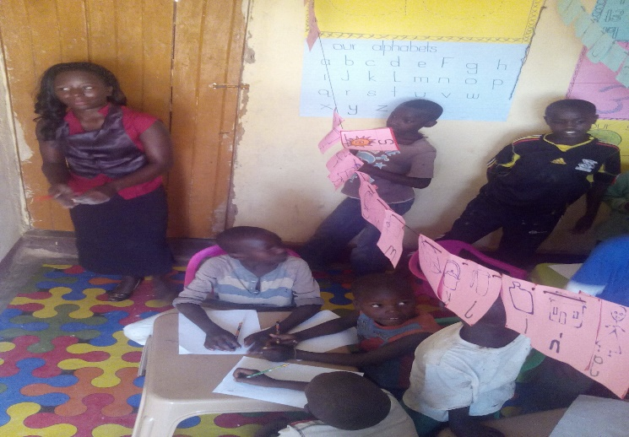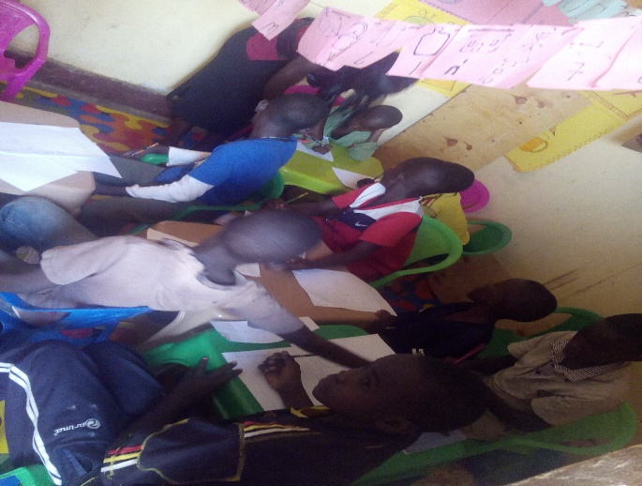
Appendix 5 & 6: Teacher Loise conducting her teaching sessions while the others stand due to the lack of chairs caused by the overwhelming number.She tries to help out one of the pupils with the basics of read and write.

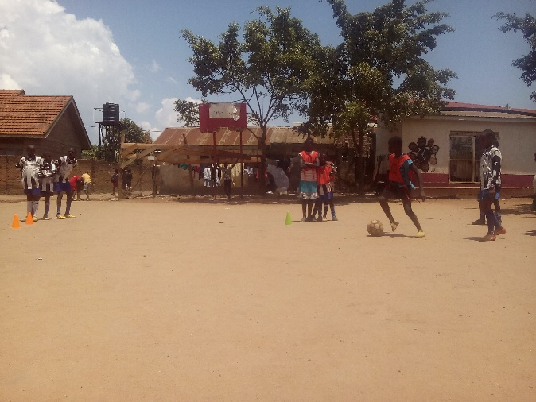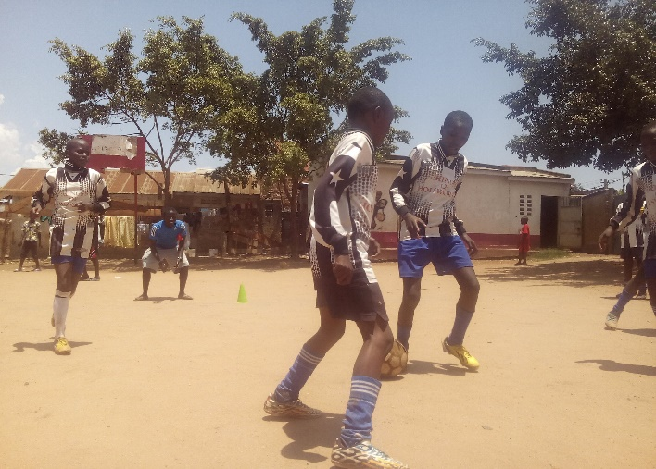
Appendix 7 & 8: The girl’s football initiative under one of the training sessions. The girls playing a friendly match between each other’s. “Sandra with the ball says she wants to be like Ronaldo”.
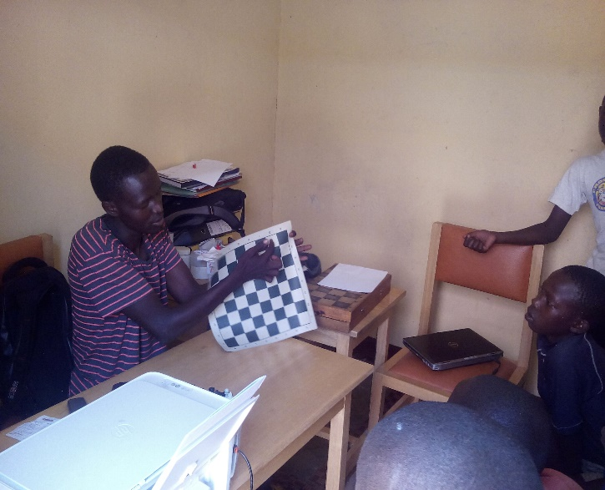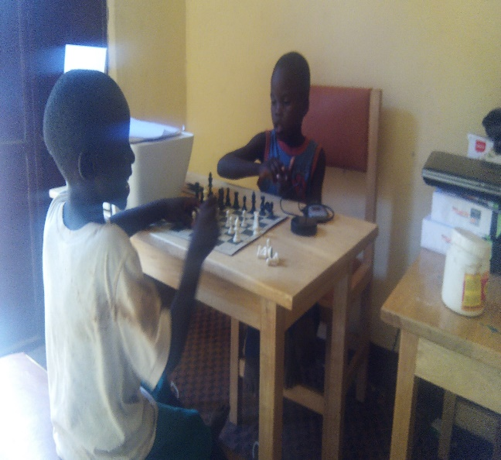
Appendix 9 &10: Ivan the Chess Coach teaching the children the steps and basics of the game. Robert and Kevin playing against each other and demonstrating what they have so far learnt about the game.

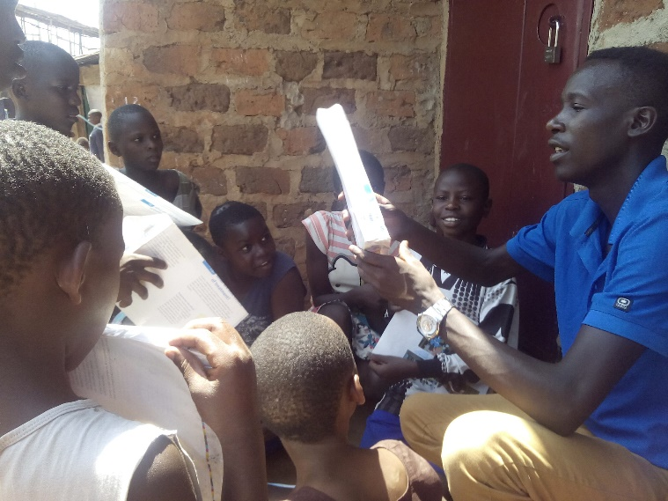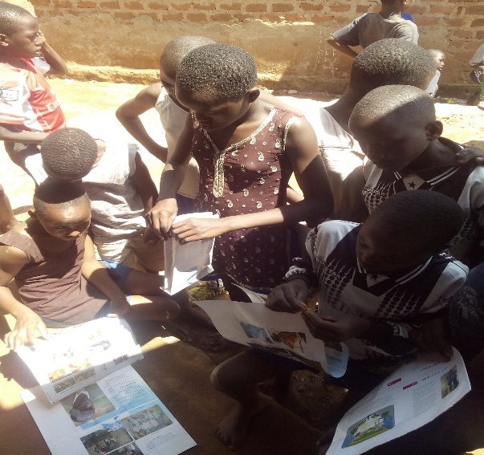
Appendix 11 & 12: Arafat teaching the girls how to make paper bags. The girls try it on their own with the instructions of the trainer.

FINANCIAL REPORT.
No | Income | Description | QTY | Unit cost | Total cost | balance | Usd
 |  | Education  School Fees  Scholastic Materials  School Uniform | 13  13  13 | 80,000  100,000  100,000 | 1,040,000  1,300,000  1,300,000
 |  | Subtotal |  | 280,000 | 3,640,000 | Nil | 1011
 |  | Welfare  Kitchen Ware  Utensils | 4  ... | 210,000  99,700 | 210,000  97,000
 |  | Subtotal |  | 309,700 | 307,000 | Nil | 85
 |  | Sports and recreational  Tournaments  Sunday league  Equipment’s  Balls | 2  3 | 75,000  80,000 | 150,000  240,000
 |  | Recreational  Chessboard | 2 | 50,000 | 100,000
 |  | Subtotal |  | 205,000 | 490,000 | Nil | 136
 |  | Earlychildhood Dev’t  Chairs  Tables  Stationery  Training Materials | 10  4  …  2 | 12,000  25,000  121,750  30,000 | 120,000  100,000  121,750  60,000
 |  | Subtotal |  | 296,750 | 401,750 | Nil | 112
 |  | Administation  Rent  Office furniture  Office Equipment’s  Printer  Extension  Modem(internet)  Salary (Tutor) | 3mths  5  1  1  1  1 | 250,000  510,000  190,000  20,000  150,000  150,000 | 750,000  510,000  190,000  20,000  150,000  150,000
 |  | Subtotal |  | 1,120,000 | 1,770,000 | Nil | 492
 |  | GRANDTOTAL |  |  | 6,608,750 |  | 1,836
N.B
1 USD = 3600 USH.

